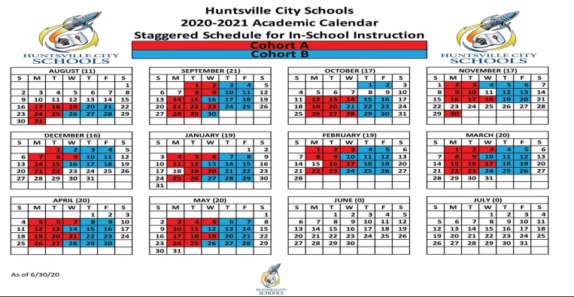
HCS Cohort Calendar for Staggered Schedule

