Chromebook Troubleshooting Guide for Parents
Use IF You Need to Sign into a Student’s Google Account on a Personal Device (HCS Chromebook is or becomes unusable):
- Navigate to www.google.com
- Sign out of your personal Google account by clicking the circle with your initial on it in the top right corner. Click Sign Out.
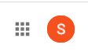
- Sign in with your child’s HCS email address and password. For most students this is their firstname.lastname@stu.hsv-k12.org You must enter their actual first name. A few students have a number added behind their last name or an abbreviated last name (if it’s long). All student passwords should be their 6-digit birthday (Ex. January 05, 2013 would be 010513). If you have a problem with your child’s account, please email Mrs. Hopkins at Jaime.hopkins@hsv-k12.org or call the HCS help desk (256) 428-6900.
- Click the “waffle” icon (next to the initial) to access the student’s Google apps.
Chromebook is Frozen:
Locate the power button on the right side of the device. Press and hold in the power button until the power indicator light goes off. Press the power button to turn the Chromebook back on.
Chromebook Keyboard or Touchpad Not Working:
You can try performing a hard reset of your Chromebook.
- Turn off your Chromebook
- Press & hold Refresh + Press & release Power button (on right side)
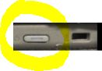
- When your Chromebook starts up, release Refresh
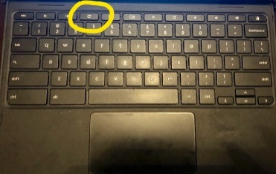
Refresh Key
Power Button
(Right Side of Device)

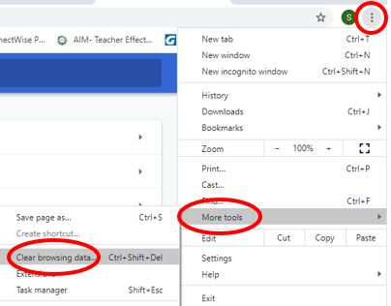
Clever Error Message or Online Programs Not Working Properly:
- Try clearing your cache in the Chrome browser
- Click the 3 vertical dots in the top right corner of Chrome
- Click More Tools
- Click Clear Browsing Data
- In the Settings tab that opens, click the drop-down arrow
in the Time Range box and select All Time
- Click Clear Data
- Close Chrome. Restart device and try again.

- Try restoring your Chrome browser
- Click the 3 vertical dots in the top right corner of Chrome.
- Click Settings
- Scroll down to the bottom of the screen and click Advanced
- Scroll down to the bottom of the screen and click Restore settings to their original defaults
- Click Reset settings
- Close Chrome. Restart device and try again.
Chromebook Screen Issues
- The screen is rotated sideways
Press CTRL + Shift + Refresh Key to rotate the screen until it’s in the correct position
- The screen is in high contrast mode (inverted colors)
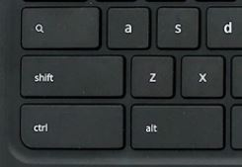
Press CTRL + Shift + H
Search Key
Keys are Typing in all Caps
Turn caps lock on or off by pressing the Search Key + Alt

Other Device Problems or Device/Charger is Unusable:
For other device problems, you can email our library media specialist Jaime.hopkins@hsv-k12.org or our ETA teacher heather.hall@hsv-k12.org call the HCS Help Desk (256) 428-6900.

